**Global Salary Trends and Workforce Analysis**

**Project Objective:**

The objective of this project is to conduct a comprehensive analysis of salary trends across various demographics and industries globally. By using advanced Excel and SQL, the study aims to identify key salary determinants such as education, experience, gender, and location. The ultimate goal is to identify key salary drivers and offer strategic recommendations to organizations for enhancing compensation structures, improving workforce satisfaction, and ensuring competitive pay scales.

**Dataset Overview:**

The dataset comprises key variables essential for salary analysis:

* **Educational Qualifications:** Examining salary variations based on academic achievements.
* **Geographic Influence:** Analyzing differences in pay scales across various regions and countries.
* **Experience-Based Compensation:** Evaluating salary progression over different career stages.
* **Gender-Based Disparities:** Investigating workforce diversity and pay equity concerns.
* **Industry-Specific Trends:** Comparing compensation benchmarks across major industries.

**Methodology:**

1. **Data Processing & Cleaning:**
   * Imported raw data into Excel for initial screening.
   * Eliminated duplicate records and handled missing entries.
   * Standardized data formats for consistency.

RAW DATA

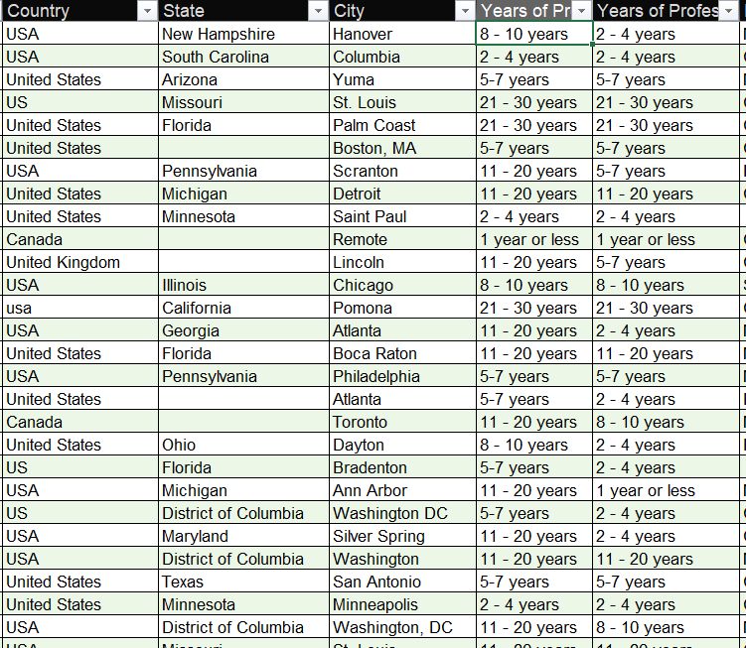

CLEANED DATA

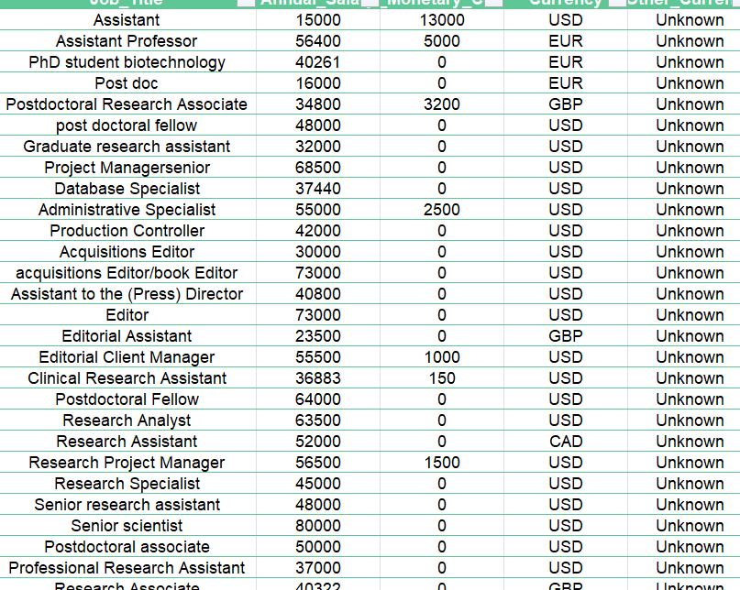

1. **Database Integration & Query Execution:**
   * Converted cleaned data into CSV format for database import.
   * Established a MySQL database and structured tables for efficient data management.
   * Applied SQL queries to extract insights on salary patterns and workforce dynamics.

Import the CSV file using the LOAD command

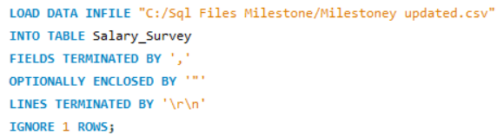

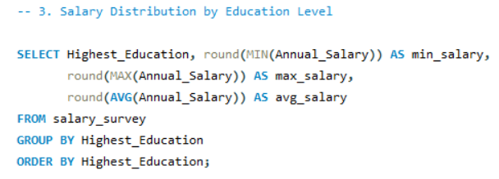

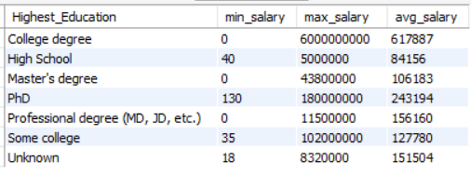

1. **Data Analysis & Visualization:**
   * Exported query results to Excel for further evaluation.
   * Developed pivot tables and charts to identify salary trends and anomalies.
2. **Dashboard Development:**
   * Designed interactive dashboards summarizing key insights.
   * Provided visual representations of salary distributions, demographic disparities, and industry benchmarks.

**Key Findings:**

* **Educational Impact:**

Higher education correlates with significant salary increases, though diminishing returns are observed at doctoral levels.

Bachelor’s degree holders earn 20-40% more than those with only high school education.

* **Experience vs. Salary Growth:**

Mid-career professionals witness the highest salary acceleration, while senior-level growth plateaus in certain fields.

* **Industry Variations:**

Technology and finance offer the most competitive salaries, while education and healthcare emphasize stability over rapid salary growth.

* **Geographical Discrepancies:**

Regional salary differences emphasize the need for location-based compensation strategies.

* **Remote Work Influence:**

Flexible work environments impact salary structures and employment benefits globally.

* **Gender Wage Gap:**

Disparities persist in multiple sectors, highlighting the need for equitable pay policies.

**Conclusion:**

The salary survey analysis provided valuable insights into salary trends and workforce management. Addressing education, experience, and diversity gaps can lead to a more balanced and competitive salary structure. The findings can help organizations implement better compensation and career development policies.